DATA STRUCTURE
LAB PROGRAMS

16. a) Priority Queue Using Max Heap and Heap sort .
#include <stdio.h>
void heapify(int arr[], int n, int i)
{
int largest = i;
int left = 2*i + 1;
int right = 2*i + 2;
if(left < n && arr[left] > arr[largest])
largest = left;
if(right < n && arr[right] > arr[largest])
largest = right;
if(largest != i)
{
int temp = arr[i];
arr[i] = arr[largest];
arr[largest] = temp;
heapify(arr, n, largest);
}
}
void heapSort(int arr[], int n)
{
for(int i = n/2 - 1; i >= 0; i--)
heapify(arr, n, i);
for(int i = n-1; i > 0; i--)
{
int temp = arr[0];
arr[0] = arr[i];
arr[i] = temp;
heapify(arr, i, 0);
}
}
int main()
{
int arr[] = {23, 56, 12, 34, 78, 29};
int n = 6;
heapSort(arr, n);
printf("Sorted Elements: ");
for(int i=0; i<n; i++)
printf("%d ", arr[i]);
return 0;
}
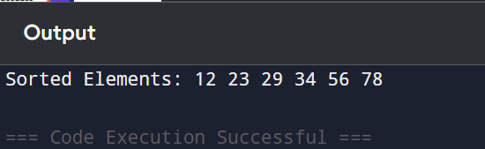

b) Priority Queue Using Min Heap and Heap sort.
#include <stdio.h>
int heap[20];
int size = 0;
void insert(int value)
{
int i = size++;
heap[i] = value;
while(i > 0)
{
int parent = (i - 1) / 2;
if(heap[parent] > heap[i])
{
int temp = heap[parent];
heap[parent] = heap[i];
heap[i] = temp;
i = parent;
}
else
break;
}
}
void display()
{
for(int i = 0; i < size; i++)
printf("%d ", heap[i]);
}
int main()
{
int arr[] = {23, 56, 12, 34, 78, 29};
for(int i = 0; i < 6; i++)
insert(arr[i]);
printf("Min Heap: ");
display();
return 0;
}
